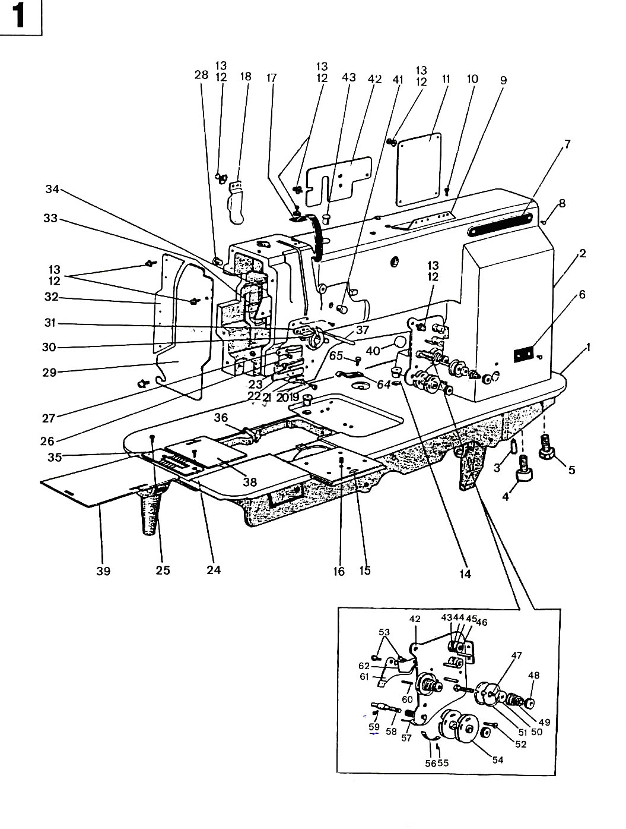
1. GC20606 Arm Parts

Item | Description | Part number | Pcs
1. | Bed | 1WF1-001 | 1
2. | Arm | 1WF1-002 | 1
3. | Pin |  | 2
4. | Screw |  | 1
5. | Screw |  | 3
6. | Trade mark plate |  | 1
7. | Model plate | 1WF1-041 | 1
8. | Nail | 1WF1-042 | 4
9. | Upper thread guide |  | 1
10. | Screw | 1WF1-015 | 2
11. | Back cover | 1WF1-016 | 1
12. | Screw | 1WF1-017 | 15
 |  | 1WF1-011
13. | Washer |  | 15
14. | Cover |  | 2
 |  | 1WF1-032
15. | Front slide plate |  | 1
 |  | 1WF1-038
16. | Screw |  | 1
 |  | 1WF1-039
17. | Thread take-up lever guard |  | 1
 |  | 1WF1-019
18. | Back front, cover |  | 1
 |  | 1WF1-030
19. | Screw |  | 1
 |  | 1WF1-027
20. | Spring |  | 1
 |  | 1WF1-028
21. | Thread retainer |  | 1
 |  | 1WF1-003
22. | Low thread finger |  | 1
 |  | 1WF1-004
23. | Screw |  | 1
 |  | 1WF1-005
24. | Screw | 1WF1-034 | 1
25. | Screw | 1WF1-036 | 1
26. | Screw | 1WF1-007 | 1
27. | Middle thread finger | 1WF1-006 | 1
28. | Rubber plug | 1WF1-018 | 2
29. | Face plate | 1WF1-013 | 1
30. | Screw | 1WF1-009 | 2
31. | Upper thread finger | 1WF1-008 | 1

Item | Description | Part number | Pcs
32. | Guide set plate | 1WF1-012 | 1
33. | Set plate | 1WF1-021 | 1
34. | Oil retainer | 1WF1-020 | 1
35. | Throat plate | 1WF1-035 | 1
36. | Pin shaft | 1WF1-037 | 1
37. | Thread releasing lever | 1WF1-023 | 1
38. | Right sliding plate | 1WF1-033 | 1
39. | Left sliding plate | 1WF1-040 | 1
40. | Plug | 1WF1-029 | 1
41. | Plug | 1WF1-022 | 1
42. | Back fitting cover | 1WF1-031 | 1
43. | Plug | 1WF1-014 | 1
44. | Thread tension set plate assembly | 1WF1-010A | 1
45. | Thread guide bracket | 1WF1-010B | 2
46. | Thread guide plate | 1WF1-010C | 2
47. | Spring | 1WF1-010D | 2
48. | Thread guide bracket screw assembly | 1WF1-010E | 2
49. | Thread releasing pin | 1WF1-010M | 1
50. | Thread tension nut | 1WF1-010H | 3
51. | Thread tension spring | 1WF1-010G | 2
52. | Thread releasing plate | 1WF1-010S | 2
53. | Thread tension plate | 1WF1-010F | 4
54. | Screw | 1WF1-010R | 1
55. | Screw | 1WF1-010Q | 2
56. | Thread control plate assembly | 1WF1-010J | 2
57. | Screw | 1WF1-026 | 1
58. | Stop plate | 1WF1-025 | 1
59. | Thread take-up spring | 1WF1-010K | 1
60. | Shaft for thread take-up spring | 1WF1-010I | 1
61. | Set screw | 1WF1-024 | 1
62. | Thread releasing pin | 1WF1-010L | 1
63. | Thread tension retaining plate | 1WF1-010W | 1
64. | Thread releasing spring | 1WF1-010P | 1
65. | Spring retaining plate | 1WF1-043 | 1
66. | Screw | 22T2-004 | 1

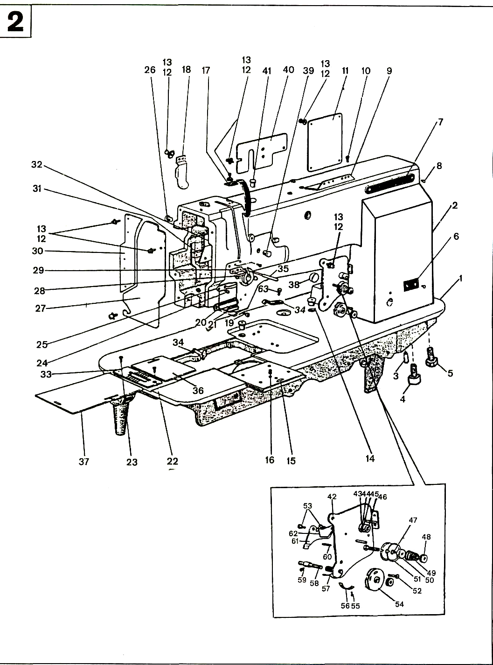
2. GC20606-1 Arm Parts

Item | Description | Part number | Pcs
1. | Bed | 9WF1-007 | 1
2. | Arm | 1WF1-002 | 1
3. | Pin |  | 2
4. | Screw |  | 1
5. | Screw |  | 3
6. | Trade mark plate | 9WF1-005 | 1
7. | Model plate | 9WF1-006 | 1
8. | Nail |  | 4
9. | Upper thread guide | 1WF1-015 | 1
10. | Screw | 1WF1-016 | 2
11. | Back cover | 1WF1-017 | 1
12. | Screw | 1WF1-011 | 15
13. | Washer |  | 15
14. | Cover | 1WF1-032 | 2
15. | Front slide plate | 1WF1-038 | 1
16. | Screw | 1WF1-039 | 1
17. | Thread take-up lever guard | 1WF1-019 | 1
18. | Back front cover | 1WF1-030 | 1
19. | Screw | 1WF1-005 | 1
20. | Low thread finger | 9WF1-001 | 1
21. | Oil felt | 9WF1-002 | 1
22. | Screw | 1WF1-034 | 1
23. | Screw | 1WF1-036 | 1
24. | Screw | 1WF1-007 | 1
25. | Middle thread finger | 1WF1-006 | 1
26. | Rubber plug | 1WF1-018 | 2
27. | Face plate | 1WF1-013 | 1
28. | Screw | 1WF1-009 | 2
29. | Upper thread finger | 1WF1-008 | 1
30. | Guide set plate | 1WF1-012 | 1
31. | Set plate | 1WF1-021 | 1

Item | Description | Part number | Pcs
32. | Oil retainer | 1WF1-020 | 1
33. | Throat plate | 9WF1-004A | 1
34. | Spring retaining plate | 1WF1-043 | 1
35. | Thread releasing lever | 1WF1-023 | 1
36. | Right sliding plate | 1WF1-033 | 1
37. | Left sliding plate | 1WF1-040 | 1
38. | Plug (Ф 14. 5) | 1WF1-029 | 1
39. | Plug (Ф 12. 7) | 1WF1-022 | 1
40. | Back fitting cover | 1WF1-031 | 1
41. | Plug(Ф 12. 7) | 1WF1-034 | 1
42. | Thread tension set plate assembly | 1WF1-010A | 1
43. | Thread guide bracket | 1WF1-010B | 1
44. | Thread guide plate | 1WF1-010C | 1
45. | Spring | 1WF1-010D | 1
46. | Thread guide bracket screw assembly | 1WF1-010E | 1
47. | Thread releasing pin | 1WF1-010M | 1
48. | Thread tension nut | 1WF1-010H | 1
49. | Thread tension spring | 1WF1-010G | 1
50. | Thread releasing plate | 1WF1-010S | 1
51. | Thread tension plate | 1WF1-010F | 2
52. | Screw | 1WF1-010R | 1
53. | Screw | 1WF1-010Q | 2
54. | Thread control plate assembly | 1WF1-010J | 1
55. | Screw | 1WF1-026 | 1
56. | Stop plate | 1WF1-025 | 1
57. | Thread take-up spring | 1WF1-010K | 1
58. | Shaft for thread take-up spring | 1WF1-003A | 1
59. | Set screw | 1WF1-024 | 1
60. | Thread releasing pin | 1WF1-010I | 1
61. | Thread tension retaining plate | 1WF1-010W | 1
62. | Thread releasing spring | 1WF1-010P | 1
63. | Screw | 22T2-004 | 1

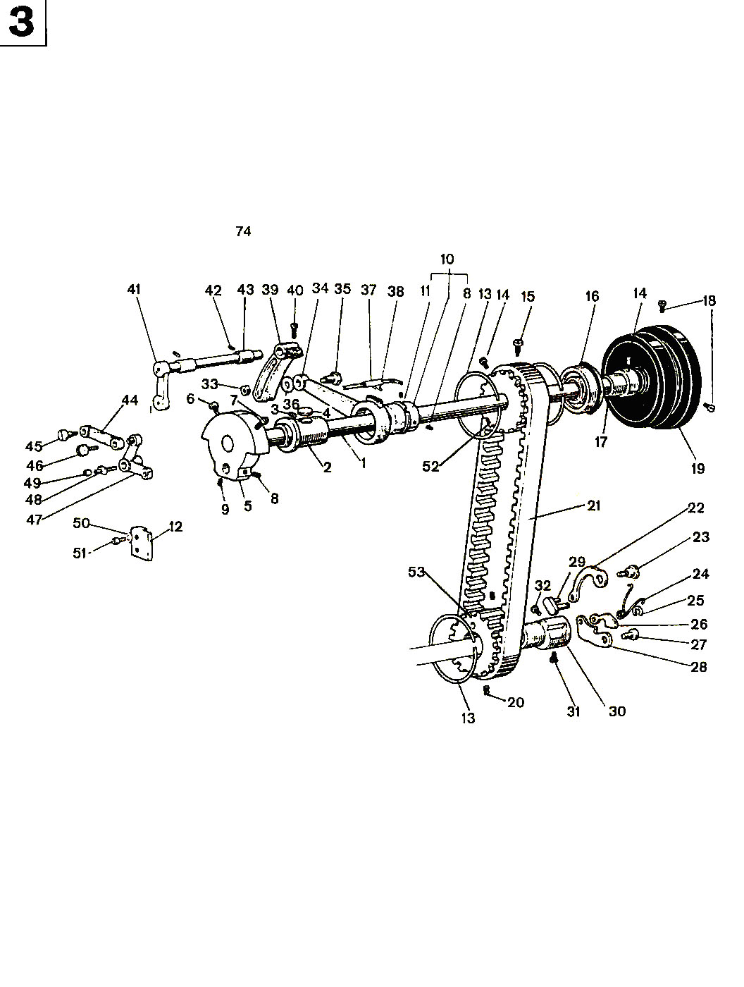
З. Upper Shaft And Presser Foot Parts

Item | Description | Part number | Pcs
1. | Upper shaft | 1WF2-025 | 1
2. | Front bushing | 1WF2-022 | 1
3. | Screw | 1WF2-023 | 1
4. | Oil felt | 1WF2-024 | 1
5. | Needle crank | 1WF2-021 | 1
6. | Screw | 1WF2-020 | 1
7. | Screw | 1WF2-007 | 1
8. | Screw | 1WF2-010 | 3
9. | Screw | 1WF2-009 | 1
10. | Presser foot lift eccentric cam | 1WF5-026 | 1
11. | Stop ring |  | 1
12. | Slot for front crank sliding block | 1WF5-041 | 1
13. | Stop ring | 1WF2-026 | 3
14. | Screw | 1WF2-030 | 3
15. | Set screw | 1WF2-029 | 1
16. | Ball bearing for upper shaft |  | 1
17. | Rear bushing for upper shaft | 1WF2-031 | 1
18. | Screw | 1WF2-019 | 2
19. | Balance wheel | 1WF2-032 | 1
20. | Screw | 1WF2-044 | 2
21. | Teeth belt | 1WF2-028 | 1
22. | Spring plate | 1WF2-039 | 1
23. | Pin for eccentric shaft | 1WF2-037 | 1
24. | Spring | 1WF2-041 | 1
25. | Split stop ring |  | 1
26. | Stop plate | 1WF2-040 | 1
27. | Nail | 1WF2-048 | 1
28. | Control plate | 1WF2-045 | 1
29. | Connection | 1WF2-042 | 1
30. | Bushing | 1WF2-046 | 1
31. | Set screw | 1WF2-047 | 1

Item | Description | Part number | Pcs
32. | Screw | 1WF2-038 | 1
33. | Nut | 1WF5-001 | 1
34. | Connecting lever | 1WF5-025 | 1
35. | Connecting screw | 1WF5-044 | 1
36. | Washer |  | 1
37. | Oil tube assembly | 1WF5-023 | 1
38. | Spring | 1WF5-024 | 1
39. | Presser foot lift rear crank | 1WF5-045 | 1
40. | Screw | 1WF4-018 | 3
41. | Presser foot lift front crank | 1WF5-038 | 1
42. | Screw | 1WF5-028 | 2
43. | Bushing | 1WF5-037 | 2
44. | Presser foot lift link | 1WF5-030 | 1
45. | Connecting screw | 1WF5-029 | 1
46. | Connecting screw | 1WF5-032 | 1
47. | Presser foot lift movable plate | 1WF5-033 | 1
48. | Shaft for needle bearing | 1WF5-034 | 1
49. | Needle bearing | 1WF5-035 | 1
50. | Washer |  | 1
51. | Screw | 1WF5-042 | 2
52. | Timing wheel | 1WF2-027 | 2
53. | Timing wheel | 1WF2-043 | 1

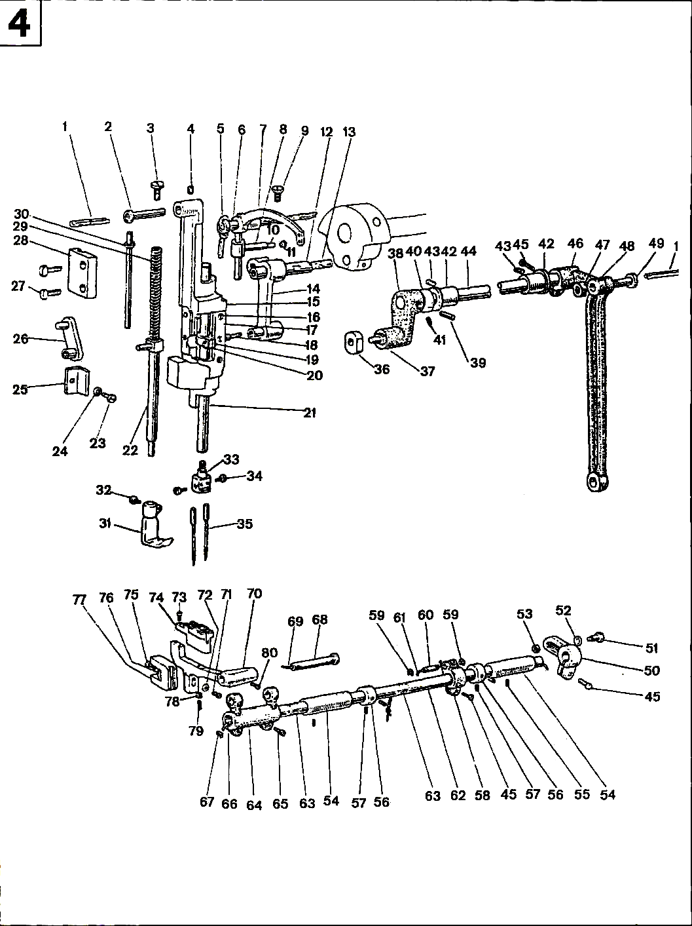
4. GC20606 Needle Bar And Lower Feed Parts

Item | Description | Part number | Pcs
1. | Oil wick | 1WF5-017 | 2
2. | Shaft for needle bar motion holder | 1WF5-018 | 1
3. | Screw | 1WF5-031 | 1
4. | Screw | 1WF5-019 | 1
5. | Oil wick | 1WF2-018 | 1
6. | Bushing for thread take-up lever hole | 1WF2-017 | 1
7. | Thread take-up lever | 1WF2-016 | 1
8. | Sliding block | 1WF2-011 | 1
9. | Screw | 1WF2-019 | 1
10. | Oil wick | 1WF2-012 | 1
11. | Plug | 1WF2-013 | 1
12. | Pin for needle bar crank | 1WF2-014 | 1
13. | Oil wick | 1WF2-015 | 1
14. | Needle bar link | 1WF2-008 | 1
15. | Needle bar motion holder | 1WF5-011 | 1
16. | Screw | 1WF5-013 | 6
17. | Shim for needle bar motion holder | 1WF5-012 | 2
18. | Oil felt | 1WF2-007 | 1
19. | Needle bar adaptor | 1WF2-005 | 1
20. | Screw | 1WF2-006 | 1
21. | Needle bar | 1WF2-004 | 1
22. | Presser bar | 1WF5-006 | 1
23. | Screw | 1WF5-010 | 1
24. | Washer |  | 1
25. | Needle bar holder guide | 1WF5-009 | 1
26. | Presser bar link | 1WF5-036 | 1
27. | Screw | 1WF3-009 | 2
28. | Needle bar motion holder guide | 1WF5-014 | 1
29. | Spring | 1WF5-016 | 1
30. | Reel for spring | 1WF5-015 | 1
31. | Alternate foot | 1WF5-043 | 1
32. | Screw | 22T2-004 | 1
33. | Needle holder | 1WF2-003 | 1
34. | Screw | 1WF2-002 | 2
35. | Needle | 1F-009 | 2
36. | Sliding block for needle bar motion | 1WF5-007 | 1
37. | Shaft for sliding block | 1WF5-008 | 1
38. | Left crank | 1WF5-020 | 1
39. | Pin |  | 1
40. | Washer | 1WF5-021 | 1
41. | Screw | 1WF5-022 | 2

Item | Description | Part number | Pcs
42. | Bushing for needle bar motion shaft | 1WF5-027 | 2
43. | Set screw | 1WF5-028 | 2
44. | Shaft for needle bar motion | 1WF5-048 | 1
45. | Screw | 1WF4-018 | 3
46. | Rear crank for needle bar motion | 1WF5-005 | 1
47. | Connecting nut | 1WF5-004 | 1
48. | Link for needle bar motion | 1WF5-003 | 1
49. | Connecting screw | 1WF5-049 | 1
50. | Right crank for feed shaft | 1WF5-002 | 1
51. | Pin for right crank | 1WF5-046 | 1
52. | Washer | 1WF5-047 | 1
53. | Nut | 1WF5-001 | 1
54. | Feed shaft bushing | 1WF4-052 | 2
55. | Set screw | 1WF2-023 | 2
56. | Collar for feed shaft | 1WF4-054 | 2
57. | Screw | 1WF2-009 | 4
58. | Feed crank | 1WF4-017 | 1
59. | Split stop ring |  | 2
60. | Pin for feed crank | 1WF4-019 | 1
61. | Oil wick | 1WF4-020 | 1
62. | Feed shaft | 1WF4-037 | 1
63. | Oil felt | 1WF4-038 | 2
64. | Feed connecting crank(left) | 1WF4-035 | 1
65. | Tension screw | 1WF4-034 | 2
66. | Oil wick clump | 1WF4-029 | 1
67. | Oil wick | 1WF4-030 | 1
68. | Shaft for feed dog support crank | 1WF4-036 | 1
69. | Oil wick | 1WF4-031 | 1
70. | Feed dog support | 1WF4-001 | 1
71. | Connecting screw | 1WF4-032 | 1
72. | Washer |  | 1
73. | Screw | 1WF4-005 | 2
74. | Feed dog | 1WF4-004 | 1
75. | Screw | 1WF4-007 | 1
76. | Oil felt for feed dog lift fork | 1WF4-008 | 1
77. | Feed dog lift fork | 1WF4-009 | 1
78. | Nut | 1WF4-002 | 1
79. | Feed dog adjusting screw | 1WF4-003 | 1
80. | Screw | 1WF4-033 | 1

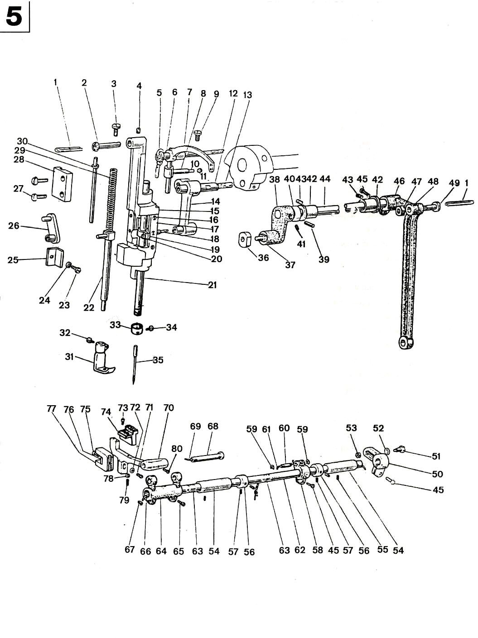
5. GC20606-1 Needle Bar And Lower Feed Parts

Item | Description | Part number | Pcs
1. | Oil wick | 1WF5-017 | 2
2. | Shaft for needle bar motion holder | 1WF5-018 | 1
3. | Screw | 1WF5-031 | 1
4. | Screw | 1WF5-019 | 1
5. | Oil wick | 1WF2-018 | 1
6. | Bushing for thread take-up lever hole | 1WF2-017 | 1
7. | Thread take-up lever | 1WF2-016 | 1
8. | Sliding block | 1WF2-011 | 1
9. | Screw | 1WF2-019 | 1
10. | Oil wick | 1WF2-012 | 1
11. | Plug | 1WF2-013 | 1
12. | Pin for needle bar crank | 1WF2-014 | 1
13. | Oil wick | 1WF2-015 | 1
14. | Needle bar link | 1WF2-008 | 1
15. | Needle bar motion holder | 1WF5-011 | 1
16. | Screw | 1WF5-013 | 6
17. | Shim for needle bar motion holder | 1WF5-012 | 2
18. | Oil felt | 1WF2-007 | 1
19. | Needle bar adaptor | 1WF2-005 | 1
20. | Screw | 1WF2-006 | 1
21. | Needle bar | 1WF2-001 | 1
22. | Presser bar | 1WF5-006 | 1
23. | Screw | 1WF5-010 | 1
24. | Washer |  | 1
25. | Needle bar holder guide | 1WF5-009 | 1
26. | Presser bar link | 1WF5-036 | 1
27. | Screw | 1WF3-009 | 2
28. | Needle bar motion holder guide | 1WF5-014 | 1
29. | Spring | 1WF5-016 | 1
30. | Reel for spring | 1WF5-015 | 1
31. | Alternate foot | 35T5-502 | 1
32. | Screw | 22T2-004 | 1
33. | Thread guide ring | 35T1-103 | 1
34. | Screw | 22T2-017 | 1
35. | Needle | 1F-009 | 1
36. | Sliding block for needle bar motion | 1WF5-007 | 1
37. | Shaft for sliding block | 1WF5-008 | 1
38. | Left crank | 1WF5-020 | 1
39. | Pin |  | 1
40. | Washer | 1WF5-021 | 1
41. | Screw | 1WF5-022 | 2

Item | Description | Part number | Pcs
42. | Bushing for needle bar motion shaft | 1WF5-027 | 2
43. | Set screw | 1WF5-028 | 2
44. | Shaft for needle bar motion | 1WF5-048 | 1
45. | Screw | 1WF4-018 | 3
46. | Rear crank for needle bar motion | 1WF5-005 | 1
47. | Connecting nut | 1WF5-004 | 1
48. | Link for needle bar motion | 1WF5-003 | 1
49. | Connecting screw | 1WF5-049 | 1
50. | Right crank for feed shaft | 1WF5-002 | 1
51. | Pin for right crank | 1WF5-046 | 1
52. | Washer | 1WF5-047 | 1
53. | Nut | 1WF5-001 | 1
54. | Feed shaft bushing | 1WF4-052 | 2
55. | Set screw | 1WF2-023 | 2
56. | Collar for feed shaft | 1WF4-054 | 2
57. | Screw | 1WF2-009 | 4
58. | Feed crank | 1WF4-017 | 1
59. | Split stop ring |  | 2
60. | Pin for feed crank | 1WF4-019 | 1
61. | Oil wick | 1WF4-020 | 1
62. | Feed shaft | 1WF4-037 | 1
63. | Oil felt | 1WF4-038 | 2
64. | Feed connecting crank(left) | 1WF4-035 | 1
65. | Tension screw | 1WF4-034 | 2
66. | Oil wick clump | 1WF4-029 | 1
67. | Oil wick | 1WF4-030 | 1
68. | Shaft for feed dog support crank | 1WF4-036 | 1
69. | Oil wick | 1WF4-031 | 1
70. | Feed dog support | 1WF4-001 | 1
71. | Connecting screw | 1WF4-032 | 1
72. | Washer |  | 1
73. | Screw |  | 2
74. | Feed dog | 9WF2-002A | 1
75. | Screw | 1WF4-007 | 1
76. | Oil felt for feed dog lift fork | 1WF4-008 | 1
77. | Feed dog lift fork | 1WF4-009 | 1
78. | Nut | 1WF4-002 | 1
79. | Feed dog adjusting screw | 1WF4-003 | 1
80. | Screw | 1WF4-033 | 1

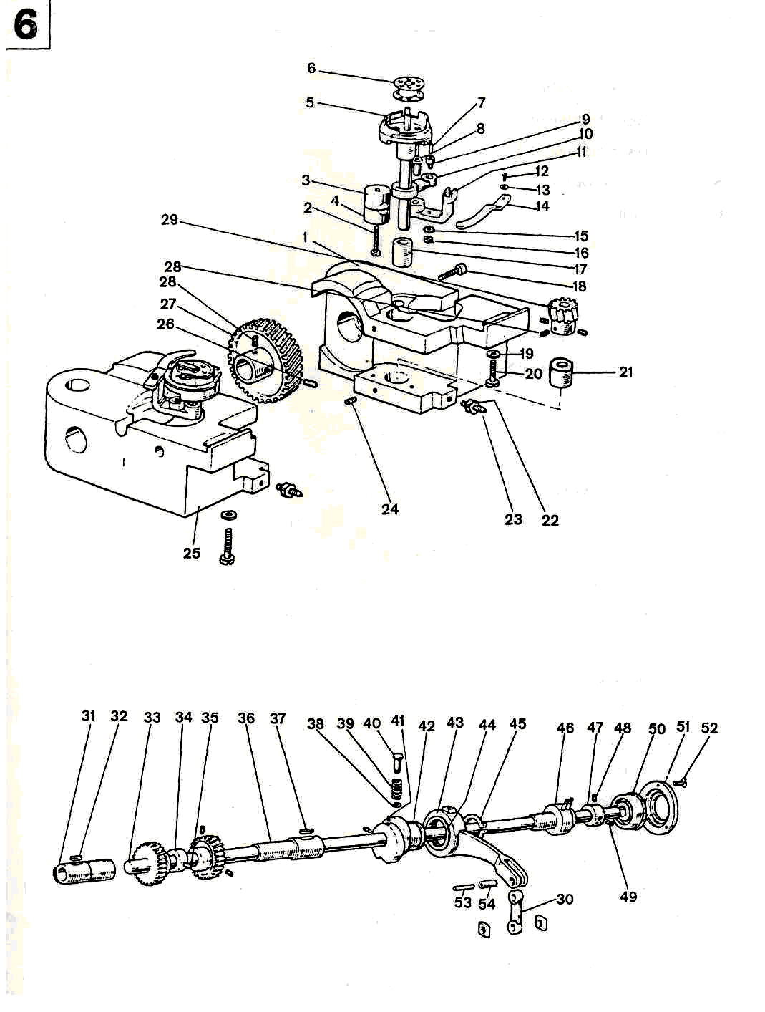
6. GC20606 Rock Shaft And Thread Looping Parts

Item | Description | Part number | Pcs
1. | Right hook saddle | 1WF2-063 | 1
2. | Screw | 1WF2-060 | 2
3. | Upper bushing of hook saddle | 1WF2-059 | 2
4. | Lower bushing of hook saddle | 1WF2-061 | 2
5. | Hook assembly | 1WF2-064 | 2
6. | Bobbin | 1WF2-065 | 2
7. | Oil wick | 1WF2-070 | 2
8. | Hinge shaft | 1WF2-069 | 2
9. | Screw | 1WF2-072 | 2
10. | Connecting lever | 1WF2-071 | 2
11. | Thread finger bracket | 1WF2-075 | 2
12. | Screw | 1WF5-026 | 2
13. | Washer |  | 2
14. | Thread finger | 1WF2-076 | 2
15. | Spring washer |  | 2
16. | Nut | 1WF2-074 | 2
17. | Bushing | 1WF2-062 | 2
18. | Set screw | 1WF2-034 | 2
19. | Washer |  | 2
20. | Tension screw for hook saddle | 1WF2-033 | 2
21. | Bushing | 1WF2-077 | 2
22. | Adjusting nut | 1WF2-067 | 2
23. | Adjusting screw | 1WF2-066 | 2
24. | Screw | 1WF2-044 | 2
25. | Left hook saddle | 1WF2-068 | 1
26. | Screw | 1WF2-052 | 2
27. | Spiral gear | 1WF2-078 | 2
28. | Screw | 1WF2-009 | 8
29. | Spiral gear | 1WF2-079 | 2
30. | Feed link | 1WF2-055 | 1
31. | Left bushing for rock shaft | 1WF2-035 | 1

Item | Description | Part number | Pcs
32. | Oil wick | 1WF2-036 | 1
33. | Rock shaft | 1WF2-056 | 1
34. | Feed dog lift cam | 1WF2-006 | 1
35. | Set screw | 1WF2-019 | 1
36. | Right bushing for rock shaft | 1WF2-057 | 1
37. | Oil wick | 1WF2-058 | 1
38. | Split stop ring |  | 1
39. | Spring | 1WF4-041 | 1
40. | Button | 1WF4-042 | 1
41. | Set screw | 1WF4-010 | 2
42. | Feed cam | 1WF4-011 | 1
43. | Feed link | 1WF4-012 | 1
44. | Needle bearing |  | 1
45. | Spring stop ring |  | 1
46. | Middle bushing assembly for rock shaft | 1WF2-055 | 1
47. | Rear bushing for rock shaft | 1WF2-051 | 1
48. | Screw | 1WF2-009 | 1
49. | Set screw | 1WF2-052 | 1
50. | Ball bearing for rock shaft |  | 1
51. | Bearing press ring | 1WF2-050 | 3
52. | Set screw | 1WF2-049 | 1
53. | Oil wick | 1WF4-044 | 1
54. | Feed link pin | 1WF4-043 | 1

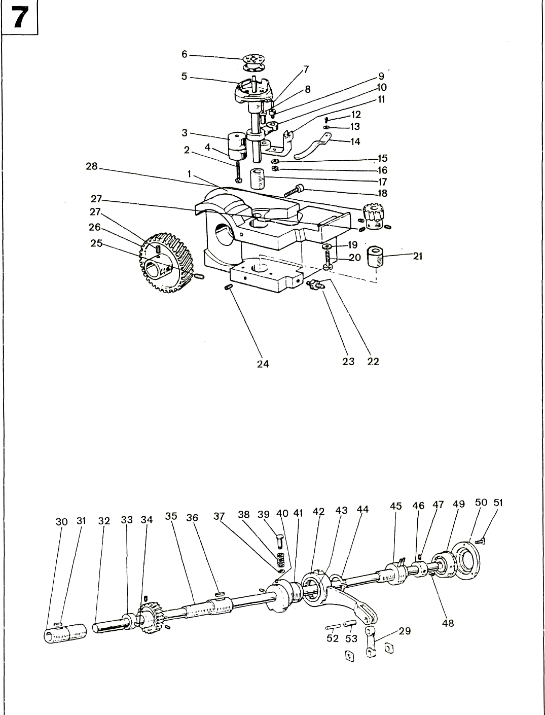
7. GC20606-1 Rock Shaft And Thread Looping Parts

Item | Description | Part number | Pcs
1. | Right hook saddle | 1WF2-063 | 1
2. | Screw | 1WF2-060 | 1
3. | Upper bushing of hook saddle | 1WF2-059 | 1
4. | Lower bushing of hook saddle | 1WF2-061 | 1
5. | Hook assembly | 1WF2-064 | 1
6. | Bobbin | 1WF2-065 | 1
7. | Oil wick | 1WF2-070 | 1
8. | Hinge shaft | 1WF2-069 | 1
9. | Screw | 1WF2-072 | 1
10. | Connecting lever | 1WF2-071 | 1
11. | Thread finger bracket | 1WF2-075 | 1
12. | Screw | 1WF5-026 | 1
13. | Washer |  | 1
14. | Thread finger | 1WF2-076 | 1
15. | Spring washer |  | 1
16. | Nut | 1WF2-074 | 1
17. | Bushing | 1WF2-062 | 1
18. | Set screw | 1WF2-034 | 1
19. | Washer |  | 1
20. | Tension screw for hook saddle | 1WF2-033 | 1
21. | Bushing | 1WF2-077 | 1
22. | Adjusting nut | 1WF2-067 | 1
23. | Adjusting screw | 1WF2-066 | 1
24. | Screw | 1WF2-044 | 1
25. | Screw | 1WF2-052 | 1
26. | Spiral gear | 1WF2-078 | 4
27. | Screw | 1WF2-009 | 2
28. | Spiral gear | 1WF2-079 | 1
29. | Feed link | 1WF2-055 | 1
30. | Left bushing for rock shaft | 1WF2-035 | 1
31. | Oil wick | 1WF2-036 | 1

Item | Description | Part number | Pcs
32. | Rock shaft | 1WF2-056 | 1
33. | Feed dog lift cam | 1WF2-006 | 1
34. | Set screw | 1WF2-019 | 1
35. | Right bushing for rock shaft | 1WF2-057 | 1
36. | Oil wick | 1WF2-058 | 1
37. | Split stop ring |  | 1
38. | Spring | 1WF4-041 | 1
39. | Button | 1WF4-042 | 1
40. | Set screw | 1WF4-010 | 2
41. | Feed cam | 1WF4-011 | 1
42. | Feed link | 1WF4-012 | 1
43. | Needle bearing |  | 1
44. | Spring stop ring |  | 1
45. | Middle bushing assembly for rock shaft | 1WF2-055 | 1
46. | Rear bushing for rock shaft | 1WF2-051 | 1
47. | Screw | 1WF2-009 | 1
48. | Set screw | 1WF2-052 | 1
49. | Ball bearing for rock shaft |  | 1
50. | Bearing press ring | 1WF2-050 | 1
51. | Set screw | 1WF2-049 | 3
52. | Oil wick | 1WF4-044 | 1
53. | Feed link pin | 1WF4-043 | 1

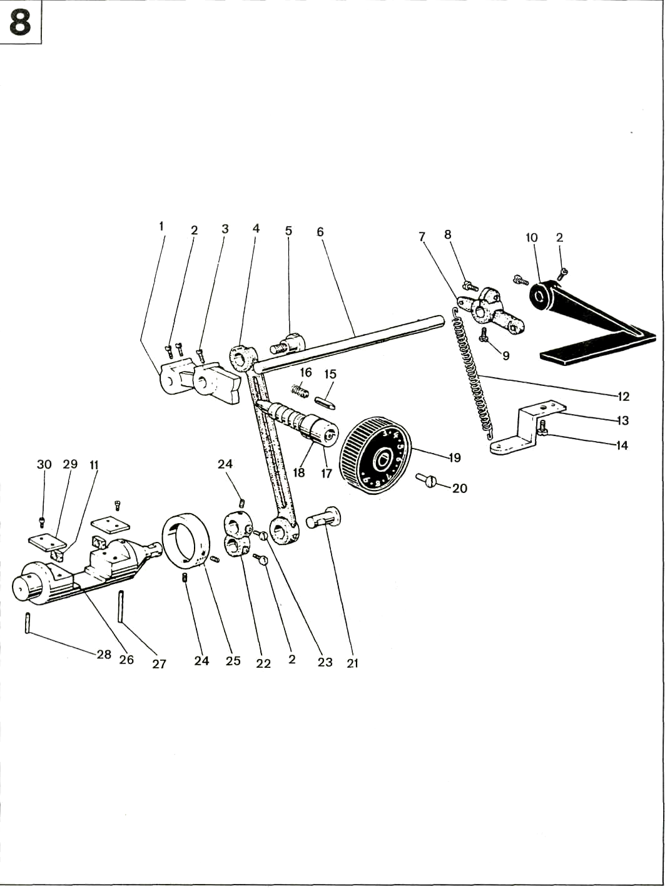
8. Stitch Length Adjusting Parts

Item | Description | Part number | Pcs
1. | Stitch length adjusting swing lever | 1WF4-025 | 1
2. | Screw | 1WF4-030 | 5
3. | Set screw | 1WF4-026 | 1
4. | Stitch length link | 1WF4-014 | 1
5. | Stitch length link eccentric shaft | 1WF4-028 | 1
6. | Reverse sewing shaft | 1WF4-046 | 1
7. | Reverse sewing crank | 1WF4-047 | 1
8. | Tension screw | 1WF4-027 | 1
9. | Set screw | 1WF4-021 | 1
10. | Reverse sewing lever | 1WF4-048 | 1
11. | Sliding block | 1WF4-040 | 2
12. | Spring | 1WF4-049 | 1
13, | Spring holder | 1WF4-050 | 1
14. | Screw | 1WF4-051 | 1
15. | Stop pin | 1WF4-024 | 1
16. | Pin spring | 1WF5-006C3 | 1
17. | Stitch length adjusting bolt | 1WF4-023 | 1
18. | 0-gasket |  | 1
19. | Stitch length dial | 1WF4-022 | 1
20. | Screw | 1WF5-009 | 1
21. | Stitch length adjusting crank shaft | 1WF4-013 | 1
22. | Stitch length adjusting crank | 1WF4-015 | 1
23. | Tension screw | 1WF2-038 | 1
24. | Set screw | 1WF4-016 | 3
25. | Collar | 1WF4-053 | 1
26. | Reverse sewing adjusting stand | 1WF4-057 | 1
27. | Oil wick | 1WF4-045 | 1
28. | Oil wick | 1WF4-039 | 1
29. | Sliding block guide | 1WF4-056 | 2
30. | Tension screw | 1WF1-011 | 4

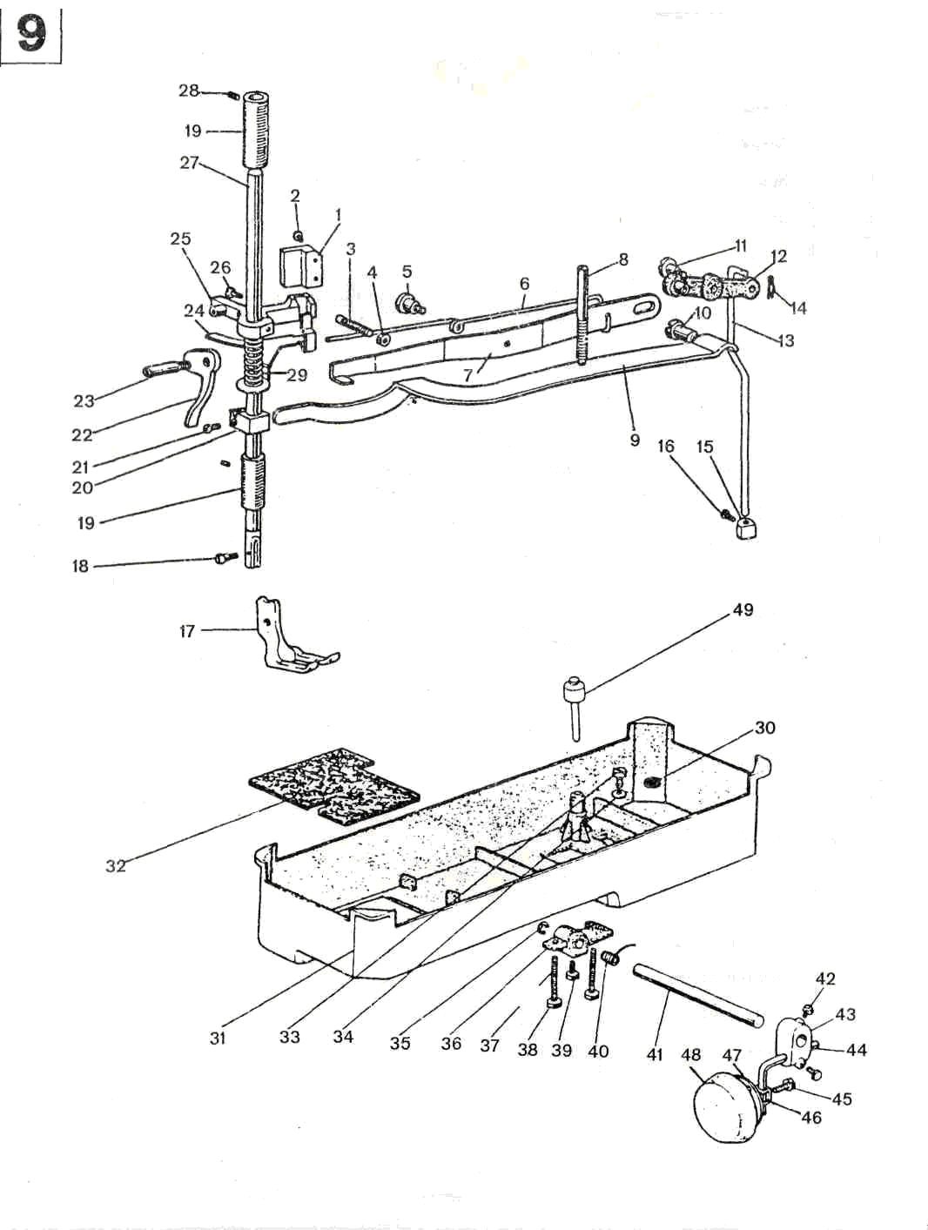
9. Presser Foot Lift Parts

Item | Description | Part number | Pcs
1. | Sliding block rail | 1WF5-040 | 1
2. | Screw | 1WF5-039 | 2
3. | Screw | 1WF3-011 | 1
4. | Nut | 1WF3-010 | 1
5. | Screw | 1WF3-013 | 1
6. | Spring | 1WF3-014 | 1
7. | Knee lift lever | 1WF3-012 | 1
8. | Pressure adjusting screw | 1WF3-015 | 1
9. | Pressure bar spring lever | 1WF3-016 | 1
10. | Screw | 1WF3-018 | 1
11. | Screw | 1WF3-017 | 1
12. | Knee control crank assembly | 1WF3-019 | 1
13. | Knee lift prop rod | 1WF3-021 | 1
14. | Split pin | 1WF3-020 | 1
15. | Stop collar | 1WF3-024 | 1
16. | Screw | 1WF3-025 | 1
17. | Presser foot | 1WF3-001(9WF3-001) | 1
18. | Set screw | 1WF3-002 | 1
19. | Bushing for presser bar shaft | 1WF3-004 | 2
20. | Spring lever holder | 1WF3-005 | 1
21. | Screw | 1WF2-006 | 1
22. | Presser foot lift lever | 1WF3-023 | 1
23. | Screw | 1WF3-022 | 1
24. | Thread releasing lever | 1WF3-007 | 1
25. | Presser bar guide | 1WF3-008 | 1
26. | Tension screw | 1WF3-009 | 1
27. | Presser bar | 1WF3-003 | 1
28. | Screw | 1WF3-023 | 2
29. | Spring | 1WF3-006 | 1
30. | Magnet | 22T9-012 | 1
31. | Oil reservoir | 58F0-001A1 | 1
32. | Oil gasket | 58F0-001 | 1

Item | Description | Part number | Pcs
33. | Screw | 22T9-001A2 | 1
34. | Washer | 22T9-001A3 | 1
35. | Retain ring |  | 1
36. | Knee lifter stop bracket | 1WF3-028 | 1
37. | Adjust screw | 22T9-001A9 | 1
38. | Adjust nut | 22T9-001A10 | 1
39. | Screw | 22T9-007C2 | 1
40. | Position spring | 22T9-001A7 | 1
41. | Hinge pin | 1WF3-027 | 1
42. | Screw | 22T9-003B4 | 1
43. | Connector | 22T9-003B3 | 1
44. | Bent rod | 22T9-003B2 | 1
45. | Screw | 22T9-003B7 | 1
46. | Knee lifter bell bracket | 22T9-003B6 | 1
47. | Bell | 22T9-003B5 | 1
48. | Pat | 22Т9-00ЗВ8 | 1
49. | Knee lifter prop ear | 1WF3-026 | 1

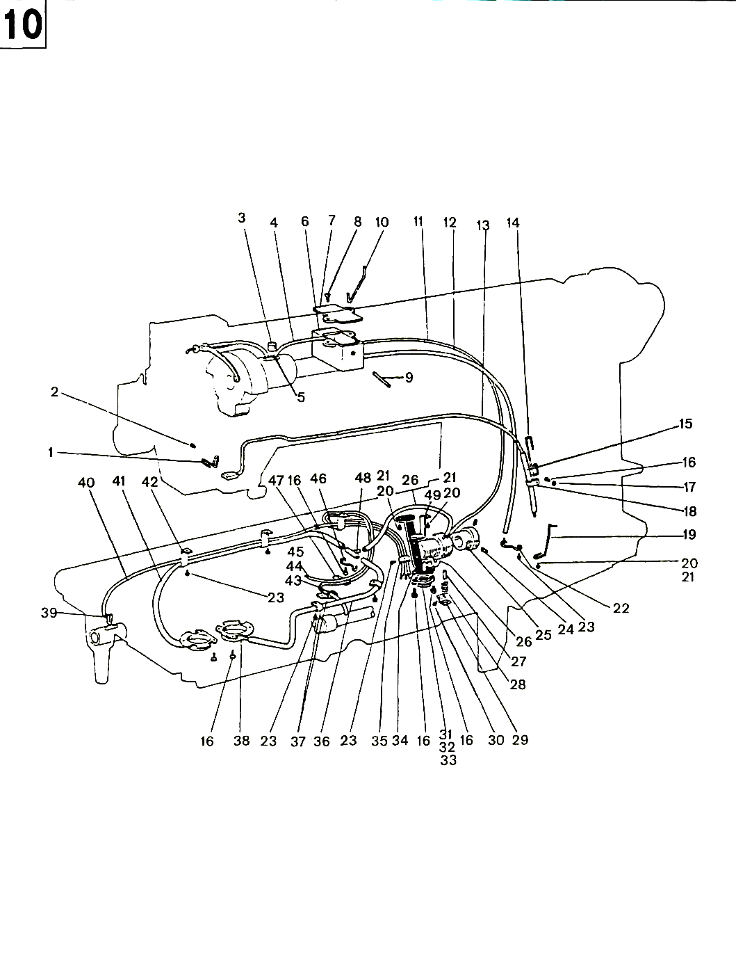
10. GC20606 Lubrication Parts

Item | Description | Part number | Pcs
1. | Oil felt press spring | 1WF6-001 | 1
2. | Screw | 1WF6-034 | 1
3. | Oil felt | 1WF6-003 | 1
4. | Oil pipe | 1WF6-005A | 1
5. | Oil wick | 1WF6-004 | 1
6. | Oil cup | 1WF6-007 | 1
7. | Oil cup cover | 1WF6-008 | 1
8. | Screw |  | 2
9. | Spring pin | 1WF6-009 | 1
10. | Wick press spring | 1WF6-006 | 1
11. | Oil pipe | 1WF6-010 | 1
12. | Oil drain pipe | 1WF6-011 | 1
13. | Oil wick | 1WF6-002 | 1
14. | Oil pipe position finger | 1WF6-013 | 1
15. | Needle bar oil return pipe | 1WF6-012 | 1
16. | Screw | 1WF6-024 | 10
17. | Washer |  | 1
18. | Oil pipe clamp | 1WF6-042 | 1
19. | Oil pipe set spring | 1WF6-014 | 1
20. | Screw | 1WF1-011 | 4
21. | Washer | 22T1-007 | 4
22. | Oil pipe end clamp | 1WF6-021 | 1
23. | Screw | 1WF1-026 | 8
24. | Screw | 1WF2-053 | 2
25. | Bushing | 1WF2-054 | 1
26. | Oil pipe | 1WF6-027 | 2
27. | Plunger | 1WF6-025 | 1
28. | Spring | 1WF6-024 | 1
29. | Braket for spring | 1WF6-023 | 1
30. | Screw | 1WF6-026 | 1
31. | Oil filter | 1WF6-018 | 1

Item | Description | Part number | Pcs
32. | Washer | 1WF6-019 | 1
33. | Filter screw | 1WF6-020 | 1
34. | Oil filter bracket | 1WF6-017 | 1
35. | Oil pipe clamp | 1WF6-028 | 1
36. | Oil pipe | 1WF6-035 | 1
37. | Pipe clamp | 1WF6-036 | 3
38. | Oil tray assembly | 1WF6-038 | 2
39. | Oil wick | 1WF6-041 | 1
40. | Oil pipe | 1WF6-040 | 1
41. | Oil pipe | 1WF6-039 | 1
42. | Pipe clamp | 1WF6-034 | 3
43. | Oil pipe | 1WF6-032 | 2
44. | Oil wick | 1WF6-037 | 1
45. | Oil wick | 1WF6-033 | 1
46. | 3-nozzle oil mouth bracket | 1WF6-030 | 1
47. | Oil pipe clamp | 1WF6-031 | 1
48. | 3-nozzle oil mouth bracket | 1WF6-029 | 1
49. | Oil filter bracket | 1WF6-015 | 1

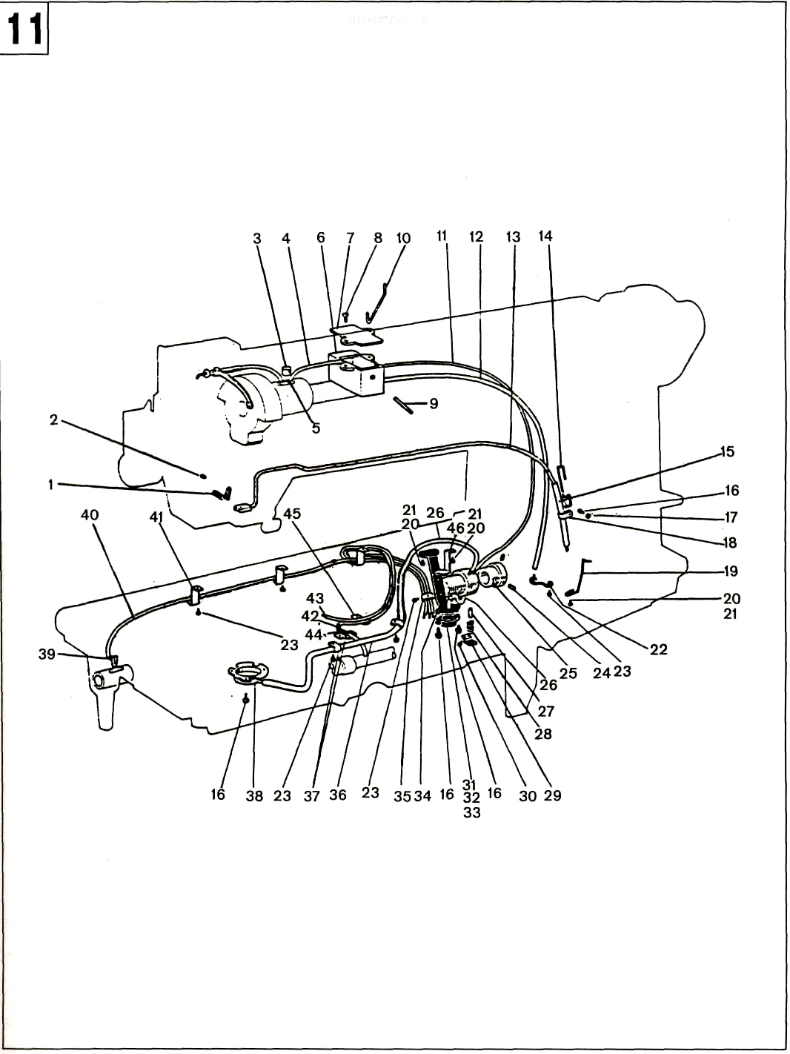
11. GC20606-1 Lubrication Parts

Item | Description | Part number | Pcs
1. | Oil felt press spring | 1WF6-001 | 1
2. | Screw | 1WF6-034 | 1
3. | Oil felt | 1WF6-003 | 1
4, | Oil pipe | 1WF6-005A | 1
5. | Oil wick | 1WF6-004 | 1
6. | Oil cup | 1WF6-007 | 1
7. | Oil cup cover | 1WF6-008 | 1
8. | Screw |  | 2
9. | Spring pin | 1WF6-009 | 1
10. | Wick press spring | 1WF6-006 | 1
11. | Oil pipe | 1WF6-010 | 1
12. | Oil drain pipe | 1WF6-011 | 1
13. | Oil wick | 1WF6-002 | 1
14. | Oil pipe position finger | 1WF6-013 | 1
15. | Needle bar oil return pipe | 1WF6-012 | 1
16. | Screw | 1WF6-024 | 10
17. | Washer |  | 1
18. | Oil pipe clamp | 1WF6-042 | 1
19. | Oil pipe set spring | 1WF6-014 | 1
20. | Screw | 1WF1-011 | 4
21. | Washer | 22T1-007 | 4
22. | Oil pipe end clamp | 1WF6-021 | 1
23. | Screw | 1WF1-026 | 8
24. | Screw | 1WF2-053 | 2
25, | Bushing | 1WF2-054 | 1
26. | Oil pipe | 1WF6-027 | 2
27. | Plunger | 1WF6-025 | 1
28. | Spring | 1WF6-024 | 1
29. | Braket for spring | 1WF6-023 | 1
30. | Screw | 1WF6-026 | 1
31. | Oil filter | 1WF6-018 | 1

Item | Description | Part number | Pcs
32. | Washer | 1WF6-019 | 1
33. | Filter screen | 1WF6-020 | 1
34. | Oil filter bracket | 1WF6-017 | 1
35. | Oil pipe clamp | 1WF6-028 | 1
36. | Oil pipe | 1WF6-035 | 1
37. | Pipe clamp | 1WF6-036 | 3
38. | Oil tray assembly | 1WF6-038 | 2
39. | Oil wick | 1WF6-041 | 1
40. | Oil pipe | 1WF6-040 | 1
41. | Pipe clamp | 1WF6-034 | 3
42. | Oil pipe | 1WF6-032 | 2
43. | Oil wick | 1WF6-037 | 1
44. | Oil wick | 1WF6-033 | 1
45. | Oil pipe clamp | 1WF6-031 | 1
46. | Oil filter bracket | 1WF6-015 | 1

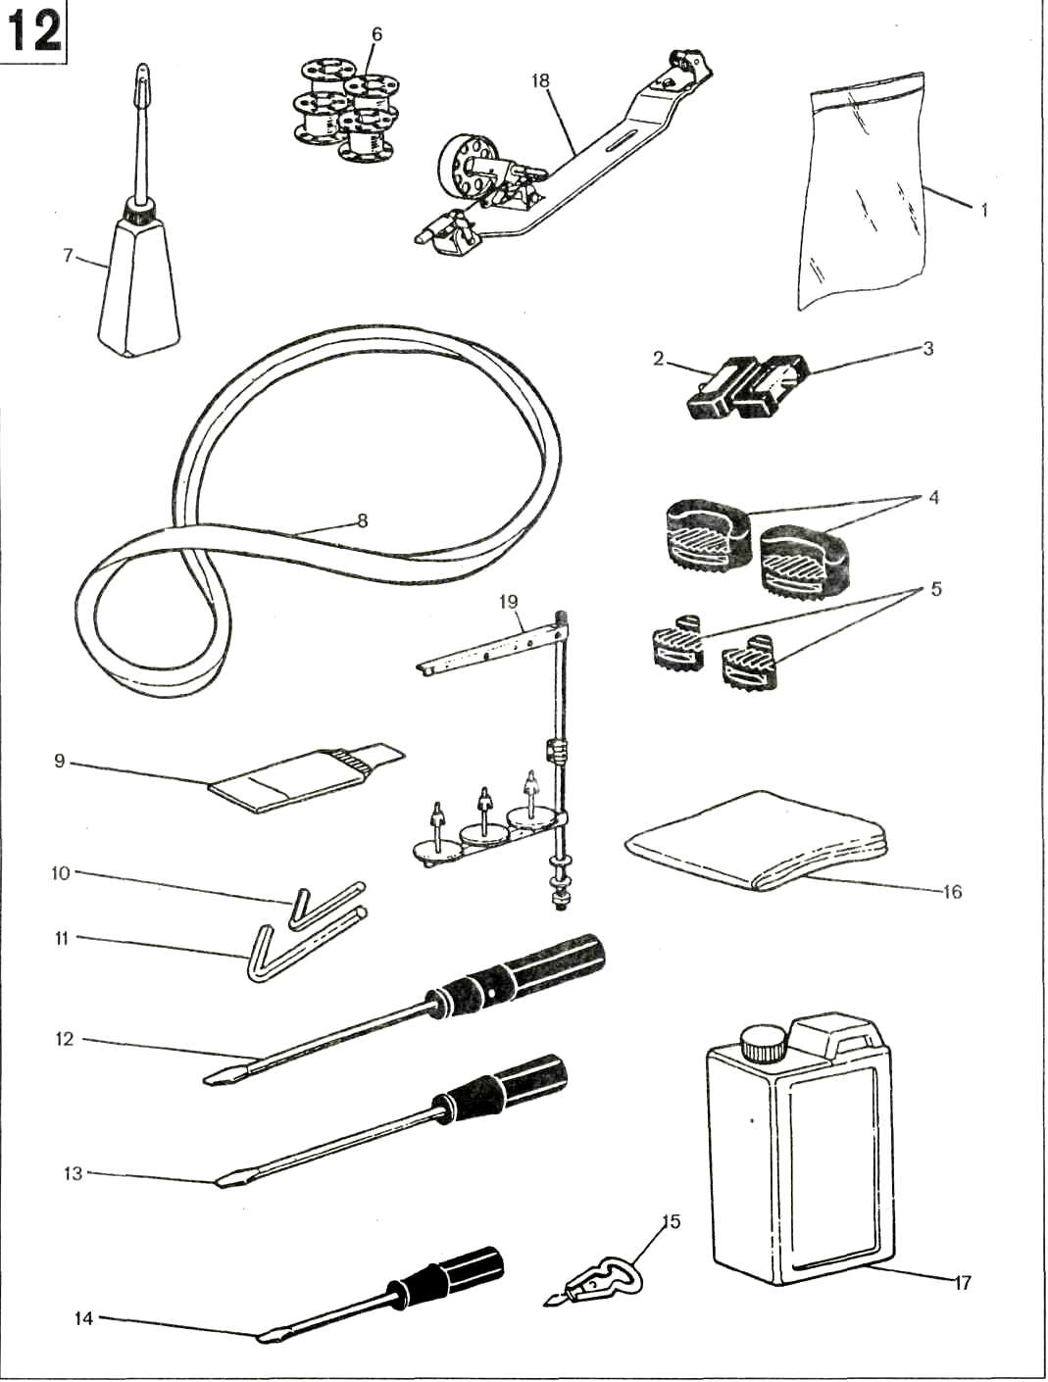

Item | Description | Part number | Pcs
1. | Accessories bag | 33TF-010 | 1
2. | Hinge pin | 22T9-007F1 | 2
3. | Hinge pin socket | 22T9-007F2 | 2
4. | Cushion | 22T9-009 | 2
5. | Cushion | 22T9-010 | 2
6. | Bobbin | 1WF2-065 | 4
7. | Oil pot | 33TF-011 | 1
8. | V-belt | 33TF-016 | 1
9. | Needle | 1F-009 | 1
10. | Hex key | 1F-011 | 1
11. | Hex key | 1F-010 | 1
12. | Screwdriver | 33TF-012 | 1
13. | Screwdriver | 33TF-013 | 1
14. | Screwdriver | 33TF-014 | 1
15. | Thread tweezer assembly | 58T0-007C | 1
16. | Arm cover | 22T9-018 | 1
17. | Oil tank | 1F-012 | 1
18. | Bobbin winder | S14420020
19. | Thread stand | 1F-014(33TF-019)

